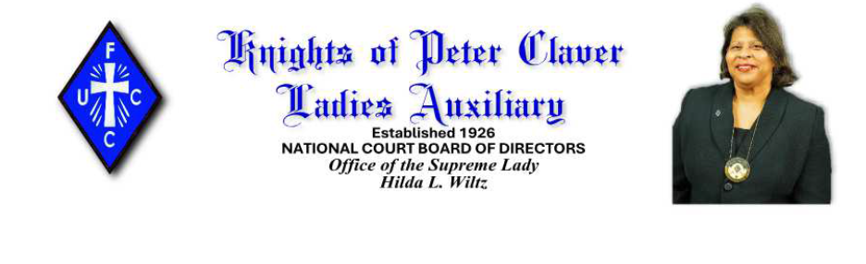Rooted in Faith, Flourishing in Service: Celebrating 100 Years of the Knights of Peter Claver Ladies Auxiliary
As we stand on the threshold of a historic milestone, the Knights of Peter Claver Ladies Auxiliary joyfully celebrates its Centennial Anniversary—a century of unwavering faith, dedicated service, and profound impact within the Catholic community. Under the inspiring theme “Rooted in Faith, Flourishing in Service,” this year-long celebration honors the legacy of those pioneering women who, in 1926, formally organized themselves into what would become one of the most influential expressions of Catholic womanhood in the United States.
The story of the Ladies Auxiliary is one of resilience and devotion. While the Knights of Peter Claver was founded in 1909 in Mobile, Alabama, the idea of a women’s auxiliary emerged as early as 1911. It was not until August 1922 that the first local court was established in Mobile, led by Lady Agnes Durette Coleman. Four years later, in August 1926, six courts convened in Galveston, Texas, during the Knights’ annual convention to officially form the National Court of the Ladies Auxiliary. Lady Marie Lula Figaro Lunnon of Houston was elected as the first Supreme Lady, setting the tone for decades of leadership and growth.
From those humble beginnings, the Auxiliary expanded steadily, overcoming skepticism and logistical challenges. By 1946—just twenty years after its founding—the Ladies Auxiliary boasted more than 4,700 members, surpassing the Knights’ division by approximately 700 members. This remarkable growth reflected not only organizational strength but also the deep spiritual commitment of its members to God, Church, and community.
Rooted in Faith
Faith has always been the cornerstone of the Ladies Auxiliary. For 100 years, its members have embodied the Gospel through service, prayer, and fellowship. As Supreme Lady Hilda L. Wiltz beautifully expressed:
“It is such a pleasure to be able to celebrate and embark upon 100 years of committed service to Claverism through the Ladies Division. As we continue our commitment to God, to Church, and to Claverism, we want to continue to be all that we can be to support the Knights of Peter Claver Inc. and all of the divisions.”
This centennial is not merely a commemoration of years passed—it is a testament to the enduring power of faith to sustain and inspire. The Auxiliary’s history is filled with examples of women who, through prayer and perseverance, built an institution that has touched countless lives. From organizing Juvenile Courts for young ladies to establishing benefits for members in times of sickness and death, the Auxiliary has always prioritized spiritual and communal well-being.
Flourishing in Service
Service is the heartbeat of the Ladies Auxiliary. Over the decades, members have championed education, supported parish life, and uplifted families and communities. Their initiatives have ranged from charitable works to leadership development, always guided by the principle that “A true Knight’s Lady comes first.”
As we celebrate this centennial, the Auxiliary continues to flourish through meaningful activities that reflect its mission. Among the announced events are:
- Tree Planting Ceremony: A living symbol of growth and renewal, commemorating both the founding and the centennial year.
- Release of the Official Centennial Prayer: Inviting all members and supporters to unite spiritually in thanksgiving and hope.
- Prayer Breakfast: A sacred gathering to honor the past and seek blessings for the future.
- Roaring ’20s Dance: A joyful nod to the decade of the Auxiliary’s birth, blending history with celebration.
- Centennial Commemorative Book: A rich chronicle of the Auxiliary’s journey, preserving stories of faith and service for generations to come.
And this is just the beginning—much more is yet to be announced, promising a year filled with opportunities to celebrate, reflect, and give thanks.
Honoring the Pioneers and Looking Ahead
This centennial is also a moment to honor the visionaries who laid the foundation. Women like Lady Marie Lula Lunnon, the first Supreme Lady; Lady Alfaretta Aubry, who led for 24 years; and countless others who organized courts across the South and beyond, deserve our deepest gratitude. Their courage and leadership transformed an idea into a thriving national organization.
Supreme Lady Wiltz reminds us:
“We celebrate our National Court Board of Directors, our State and District Deputies, all of the Past Supreme Ladies, all of the members. We are going to be celebrating, praying, and hoping that another 100 years will be as successful as the last. We ask you to continue to pray with us for all those who have gone before us, laying the foundation.”
Indeed, as we look to the future, we do so with confidence and hope. The Auxiliary’s commitment to faith and service remains as strong as ever. With God’s grace, the next century will bring new opportunities to evangelize, educate, and empower.
To God Be the Glory
As we enter this new year, the centennial celebration carries a special resonance. It reminds us that every good work begins and ends with God. Supreme Lady Wiltz offers a heartfelt greeting:
To God be the glory for the past 100 years—and for the promise of the years to come. Rooted in faith, flourishing in service, the Knights of Peter Claver Ladies Auxiliary stands as a beacon of Catholic womanhood, a testament to what can be achieved when faith and action unite.

